The Book of
Revelation
Lesson Number Three
“Walk Through the Bible” Series
© 2016 by Jay S. McMullan

We must remember the book of Revelation is in chronological order. If we miss this truth, our whole understanding of Revelation will be skewed.

Revelation 1:19 (KJV)
¹⁹ Write the things which thou hast seen, and the things which are, and the things which shall be hereafter;

John was told to write what he had seen (his vision of Christ appearing to him on the Island of Patmos), the things which are (Jesus dictating the letters to the seven churches, and what would happen hereafter (after the Rapture when the Church, as a whole, is removed from the earth).

Revelation can be broken down into Three main parts.
Part I – Things which thou hast seen – Chapter One.
Part II – The things which are now (in John’s present time, the Church age, or Age of Grace which is also OUR TIME) – Chapters Two and Three
Part III – The things which shall be hereafter – The things that will take place after this age – Chapters Four through Twenty-Two.

The Letters to the Seven Churches

John had a previous relationship with these seven churches. It is known that he had preached in this area throughout his life and ministry before this Revelation.

The order of these cities corresponds to “the route along which a courier from Patmos [where John received the vision] would have carried the scroll” (ESV Study Bible, Revelation 2:11).

The Letters to the Seven Churches

There were certainly other churches. These were not all of them. The Church was also established at Corinth, Colossae and Philippi, just to name a few.

Teachers of Revelation have interpreted the meaning of these letters in different ways.
● Some say that each church represents a different time period.
● Some say that each church represents a different group of people.
● Some believe the letters show the chronological church or church eras.

Addressing this perspective, the late professor Dr. John F. Walvoord notes: “Many expositors believe that in addition to the obvious implication of these messages the seven churches represent the chronological development of church history viewed spiritually. They note that Ephesus seems to be characteristic of the Apostolic Period in general and that the progression of evil climaxing in Laodicea seems to indicate the final state of apostasy of the church. … The order of the messages to the churches seems to be divinely selected to give prophetically the main movement of church history” (John Walvoord, The Revelation of Jesus Christ, 1989, pp. 51-52).
http://lifehopeandtruth.com/prophecy/revelation/seven-churches-of-revelation/

God selected these seven congregations to give timeless instruction for His people throughout the centuries (in the Church Age).

The book of Revelation is addressed to the seven churches, yet it is applicable to all peoples of the present time.

We should not refrain from studying the book of Revelation for the mere reason that we fear we may not be able to understand it.

We should pray that the Holy Spirit will help us grow in the knowledge and Grace of God. The Holy Spirit will teach us if we study with a humble mind and heart!

2 Timothy 3:15-17 (NLT)
¹⁵ You have been taught the holy Scriptures from childhood, and they have given you the wisdom to receive the salvation that comes by trusting in Christ Jesus. ¹⁶ All Scripture is inspired by God and is useful to teach us what is true and to make us realize what is wrong in our lives. It corrects us when we are wrong and teaches us to do what is right. ¹⁷ God uses it to prepare and equip his people to do every good work.

Each of the Letters to the seven Churches has a Three-Fold Application!

- A local application to the churches in John’s day.
These seven letters or epistles, as a whole, portray actual conditions in these seven local churches in Asia Minor.

- A prophetical application to the churches throughout this dispensation (Age of Grace or Church Age) up to the Rapture, revealing the spiritual conditions of local churches and individuals in the churches. This point is clear from the fact that the book is a “prophecy.” Then too, these letters are as applicable to the saved all through this age as are the other New Testament epistles and other scriptures. 2 Tim. 3:16, 17.

Before we started our series on the book of Genesis in 2015, I did three lessons on “Dispensations.” I talked about the differing dispensations or ages that mankind has gone through.

We are currently living in the “Age of Grace” or the “Church Age.”

It is my opinion that the Age of Grace began when Jesus was resurrected from the dead, victorious over death and hell themselves! He was given the keys to death and hell.

It was just a short matter of time before human beings were saved as we see in the Gospel of John.

John 20:19-22 (NLT)
¹⁹ That Sunday evening the disciples were meeting behind locked doors because they were afraid of the Jewish leaders. Suddenly, Jesus was standing there among them! “Peace be with you,” he said. ²⁰ As he spoke, he showed them the wounds in his hands and his side. They were filled with joy when they saw the Lord! ²¹ Again he said, “Peace be with you. As the Father has sent me, so I am sending you.” ²² Then he breathed on them and said, “Receive the Holy Spirit.”
Then, when Jesus ascended, He “took captivity captive” taking all of the righteous souls in Abraham’s Bosom to Heaven with Him.

This was the beginning of the Church Age. It will conclude when we (the Church) return with Jesus at His second coming seven years after the Rapture.

These letters are as applicable to all other Churches in the Church Age as are the rest of the epistles in the Bible. We don’t teach that the book of Ephesians applied ONLY to the Church in Ephesus or that the book of Romans applied ONLY to Christians in Rome.

All of the Epistles in the Bible (Romans through Revelation) had a local application to the Churches they were addressed to and more.

It is the same with these letters. They apply to the Churches they are addressed to as well as to the rest of the Churches throughout the Age of Grace, up until the time of the Rapture.

Dake states, “local conditions in them (the seven churches) are characteristic of the course of this age and they are concrete examples to local churches throughout the dispensation.”

If these letters were confined to ONLY the seven churches in Asia Minor there would be no universal call to individuals with ears to hear, to hear and to overcome throughout this age!

- An individual application, so that the individual may be warned by the failure revealed therein and profiting by the warning, may find encouragement from the promises to the overcomer.

“The dispensational application of these church letters; i.e., that they portray seven Church periods or phases of Church history is really based upon human theory alone. There can be no Scripture produced to prove this theory in any one aspect. Similarity to certain phases of church history proves nothing.” Dake

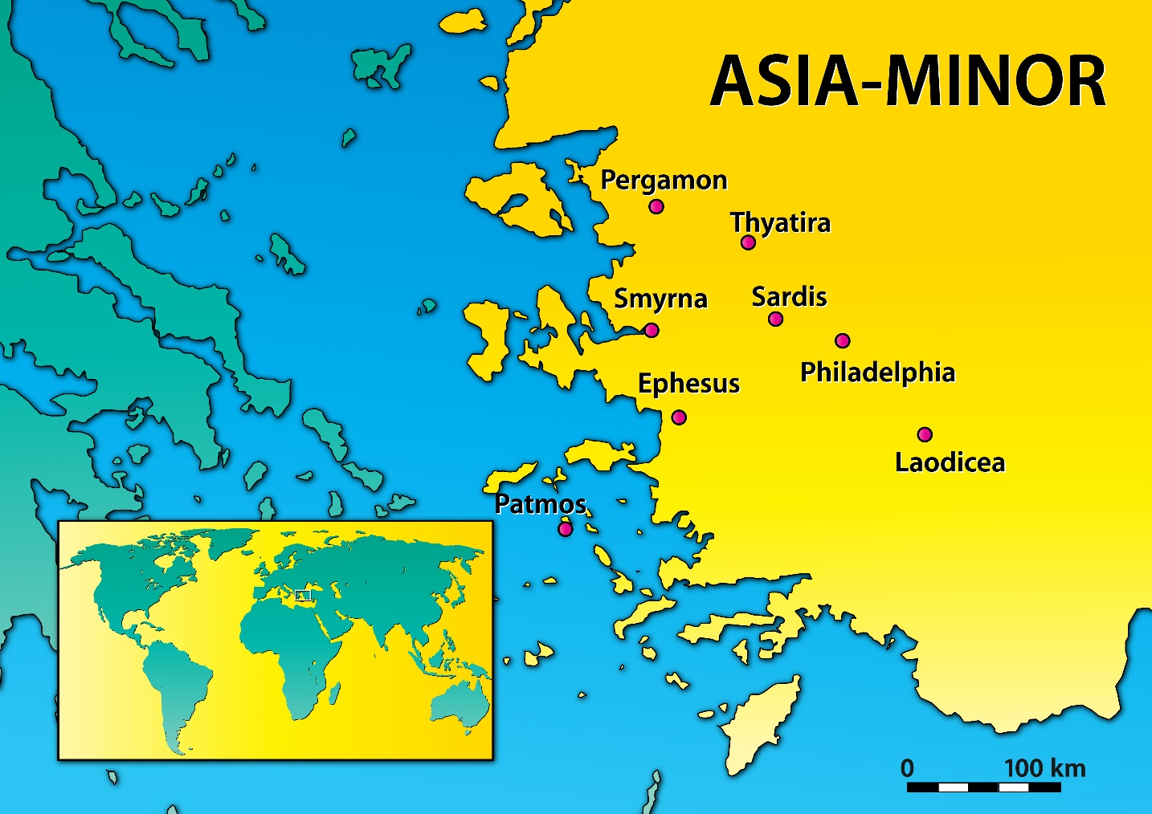
http://sunnybankchurch.com.au/wp-content/uploads/2016/09/SevenChurchesOfAsiaMinor.jpg

The Letter to the Church at Ephesus

Revelation 2:1-7 (NLT)
¹“Write this letter to the angel of the church in Ephesus. This is the message from the one who holds the seven stars in his right hand, the one who walks among the seven gold lampstands: ²“I know all the things you do. I have seen your hard work and your patient endurance. I know you don’t tolerate evil people. You have examined the claims of those who say they are apostles but are not. You have discovered they are liars. ³ You have patiently suffered for me without quitting. ⁴ “But I have this complaint against you. You don’t love me or each other as you did at first! ⁵Look how far you have fallen! Turn back to me and do the works you did at first. If you don’t repent, I will come and remove your lampstand from its place among the churches. ⁶But this is in your favor: You hate the evil deeds of the Nicolaitans, just as I do. ⁷“Anyone with ears to hear must listen to the Spirit and understand what he is saying to the churches. To everyone who is victorious I will give fruit from the tree of life in the paradise of God.

- God KNOWS everything we do! (v.2)
  - God saw their hard work
    - The things you do for God WILL be rewarded!
2 Timothy 2:15 (NLT)
¹⁵ Work hard so you can present yourself to God and receive his approval. Be a good worker, one who does not need to be ashamed and who correctly explains the word of truth.

  - Their patient endurance
    - Without patience you will never live a victorious life!
    - God rarely ever moves on our timeline.
    - God moves on His timeline which is always perfect!
  - Their intolerance for evil people
  - They checked out minister’s credentials
Acts 17:10-11 (KJV)
¹⁰ And the brethren immediately sent away Paul and Silas by night unto Berea: who coming thither went into the synagogue of the Jews. ¹¹ These were more noble than those in Thessalonica, in that they received the word with all readiness of mind, and searched the scriptures daily, whether those things were so.

  - They suffered patiently for the Lord without quitting

- “Everything about the Ephesian church looked good on the outside, but inwardly they had heart trouble. Their devotion to Christ was waning.” (David Jeremiah)

- They lost their first love for God and for each other (v. 4)

- Christ gives these instructions:
  - “Turn back to Me.”
  - “Do the works you first did.”

- What would happen if they did not repent (change their ways)
  - God would “remove their lampstand from its place among the churches.”
  - “removal” Grk. Kineo – “Removing a church because of sin indicates judgment and destruction, for this is the only penalty for sin (Rom. 6:23; 8:12-13).”
Dake's Annotated Reference Bible: Containing the Old and New Testaments of the Authorized or King James Version Text.
  - As Christians, WE CAN resist the temptations of the flesh!
Romans 8:12-13 (NLT)
¹² Therefore, dear brothers and sisters, you have no obligation to do what your sinful nature urges you to do.¹³ For if you live by its dictates, you will die. But if through the power of the Spirit you put to death the deeds of your sinful nature, you will live.

- The thing they did that God approved of:
  - They hated the evil deeds of the Nicolaitans, just as God did. (v.6)
Nicolaitans
“The exact origin of the Nicolaitans is unclear. Some Bible commentators believe they were a heretical sect who followed the teachings of Nicolas—whose name means “one who conquers the people”—who was possibly one of the deacons of the early church mentioned in Acts 6:5. It is possible that Nicolas became an apostate, denying the true faith and became part of a group holding "the doctrine of Balaam," who taught Israel "to sin by eating food sacrificed to idols and by committing sexual immorality." Clement of Alexandria says, “They abandoned themselves to pleasure like goats, leading a life of self-indulgence.” Their teaching perverted grace and replaced liberty with license.”
“Other commentators believe that these Nicolaitans were not so called from any man, but from the Greek word Nicolah, meaning "let us eat," as they often encouraged each other to eat things offered to idols. Whichever theory is true, it is certain that the deeds of the Nicolaitans were an abomination to Christ. They, like the Gnostics and other false teachers, abused the doctrine of grace and tried to introduce licentiousness in its place (2 Peter 2:15, 19; Jude 1:4).”
https://www.gotquestions.org/Nicolaitans.html

Peter and Jude both wrote about false teachers that had infiltrated the Church in their time. This has happened since the inception of the Church and will continue until Christ’s return.

2 Peter 2:15,19 (NLT)
¹⁵ They have wandered off the right road and followed the footsteps of Balaam son of Beor, who loved to earn money by doing wrong.
¹⁹ They promise freedom, but they themselves are slaves of sin and corruption. For you are a slave to whatever controls you.

Jude 1:4 (NLT)
⁴ I say this because some ungodly people have wormed their way into your churches, saying that God’s marvelous grace allows us to live immoral lives. The condemnation of such people was recorded long ago, for they have denied our only Master and Lord, Jesus Christ.

- Instruction to the Church
“Anyone with ears to hear must listen to the Spirit and understand what He is saying to the Churches.

- To those who are victorious and overcome:
  - “I will give fruit from the tree of life in the paradise of God.”

The Tree of Life

The tree of life first appeared in the Garden of Eden.

Genesis 2:9 (NLT)
⁹ The LORD God made all sorts of trees grow up from the ground—trees that were beautiful and that produced delicious fruit. In the middle of the garden he placed the tree of life and the tree of the knowledge of good and evil.

When Adam and Eve sinned, they HAD to be removed from the Garden before they ate of the tree of life. Had they done so, mankind would have lived forever in a fallen state, or in the second death. There would have never been any chance for Jesus to offer atonement to mankind!
The next time we see the tree of life is in Heaven.

Revelation 22:1-3 (NLT)
¹ Then the angel showed me a river with the water of life, clear as crystal, flowing from the throne of God and of the Lamb. ² It flowed down the center of the main street. On each side of the river grew a tree of life, bearing twelve crops of fruit, with a fresh crop each month. The leaves were used for medicine to heal the nations. ³ No longer will there be a curse upon anything. For the throne of God and of the Lamb will be there, and his servants will worship him.

The tree bears twelve crops of fruit, each and every month.
The leaves are used for medicine to heal the nations.
There will no longer be curses, they will not exist.
The throne of God and the Lamb will be here and His servants will worship God!

There are more than one Tree of Life. There is also the Tree of the Knowledge of Good and Evil from which Adam and Eve ate the forbidden fruit. It is possible that there are more than one of these too.

It could be that these species of trees exist today but due to man’s fall, they are in their fallen state just as man is and because of this, they may not produce the same fruit as they did before the fall and as they will after everything is restored.

